*Name: Rahman, Sheikh Talha Jubayer*

*ID: 19-41468-3*

**Case 1:**

In a library management system, a member may rent many books. One book may be rented by exactly one member. A member is identified by a member number. The system also stores member name and address. A member address is composed of house number, street name and city. A book is identified by book ID. Book name, ISBN Number and edition of a book are also stored. There may be multiple editions of a book. While borrowing, the date of the borrowing and copy number of the book is stored. A member may also reserve many books. A book may be reserved by many members. To find the priority of the reservation the date of making the reservation is also stored. A book is written by at least one author. An author may write many books but the system stores information of those authors of who has written at least one book stored in the library. To identify an author the system stores author ID along with author name. A book belongs to exactly one category and for a category there must be at least one book. Each category has a name and the unique property of each category is a category number.

ER Diagram:

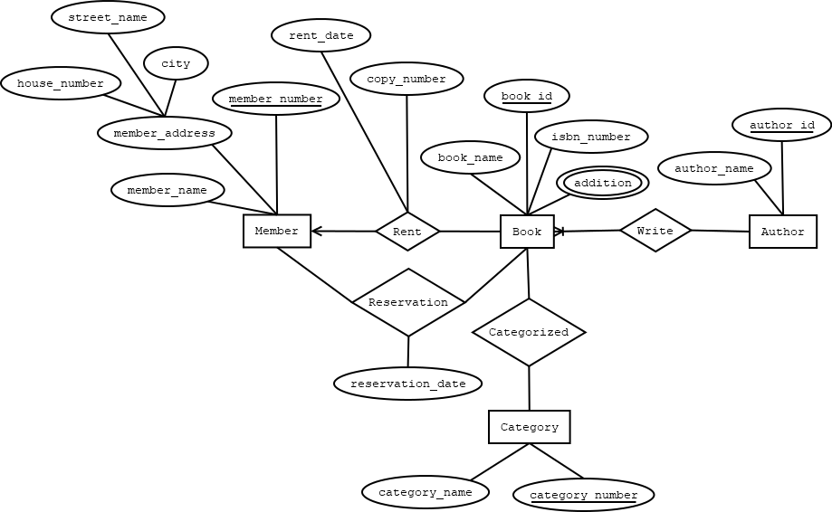

**Case 2:**

In a University Management System, a student can attend class. Every class must have a student associated with it via attendance. Every student does not have to be associated with class via attendance. Class has sections. The existence of section is totally dependent on class. Class is taken by teacher. Lecturer and Professor can be generalized as teacher. Student can register for course. Course is made of lectures. Lectures contain assignment. Assignment can be specialized into homework, exam and project. Guardians can come and enquire about course and lecture. Now draw an ER diagram according to the mentioned scenario.

ER Diagram:

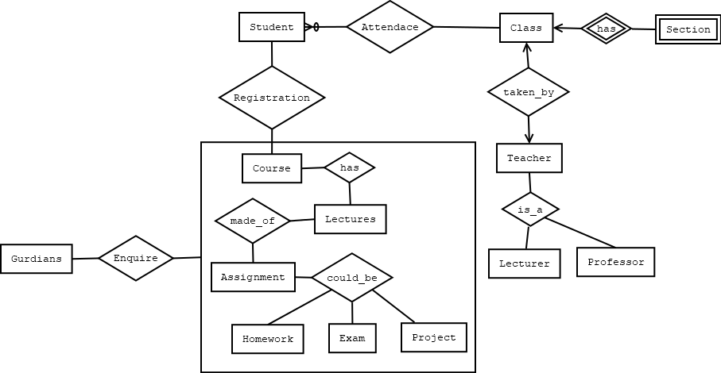

**Case 3:**

Design an E-R diagram for keeping track of the exploits of your favorite sports team. You should store the matches played, the scores in each match, the players in each match and individual player statistics for each match. Summary statistics should be modeled as derived attributes. 5. Extend the E-R diagram of the previous question to track the same information for all teams in a league.

ER Diagram:

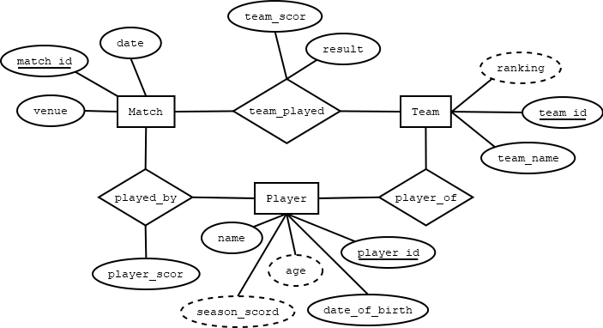

**Case 4:**

In a Messaging System, a user may or may not have friendship with other users. One user can have zero to many friendships. User is identified by user id. System also stores user name, user date of birth, phone number, age and address. User’s age is driven by user’s date of birth. User can have multiple phone number. Users’ address is composed of city, area and street. Street is also composed of road number and road name. One friendship is created by exactly two users. Friendship is identified by friendship id which contain users id. One friendship has friendship type like family, close and only friend. System also store the friendship starting date. One user can be member of zero to many groups. One group is identified by group id. One group is created by more than two members. Group has name and group type like entertainments, study and work. System also store group opening date. Group and friendship both may have zero to many messages. User can send zero to many messages to friendships and groups. System stores sending date when a user send a message. One message can be sent by exactly one user to friendship or group. One message belongs to exactly one friendship or group. One message is identified by message id which is made of friendship id or group id. Message has the text and sender id which is the user id who send this message.

ER Diagram:

